Hi Sunny –

Great news – short trades now work when using the api! We are now close to having the market maker script capable of implementing the trading logic.

There are a few things I noticed that aren’t working correcting with the grab_current_inventory() function. I have tried to summarize them below:

1 – Current Net Liquidation Value

I’m not totally sure where Current Net Liquidation Value is getting its value from. Please see below. The current balance of the account is ~$315, but the number shown below is far lower than that. I THINK that the value reflected here is the total left-over USD, and that its not reflecting the value of any short positions. When I took this screen shot, the account was short approximately -.20 ETH (so the max short position allowed while using 2x leverage).

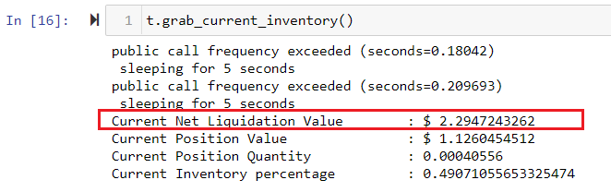

The actual value we want to pull is named “Equity” (please see the below screenshot). Total account equity is a more accurate measure of the account’s value at the given moment, which is what we are after.

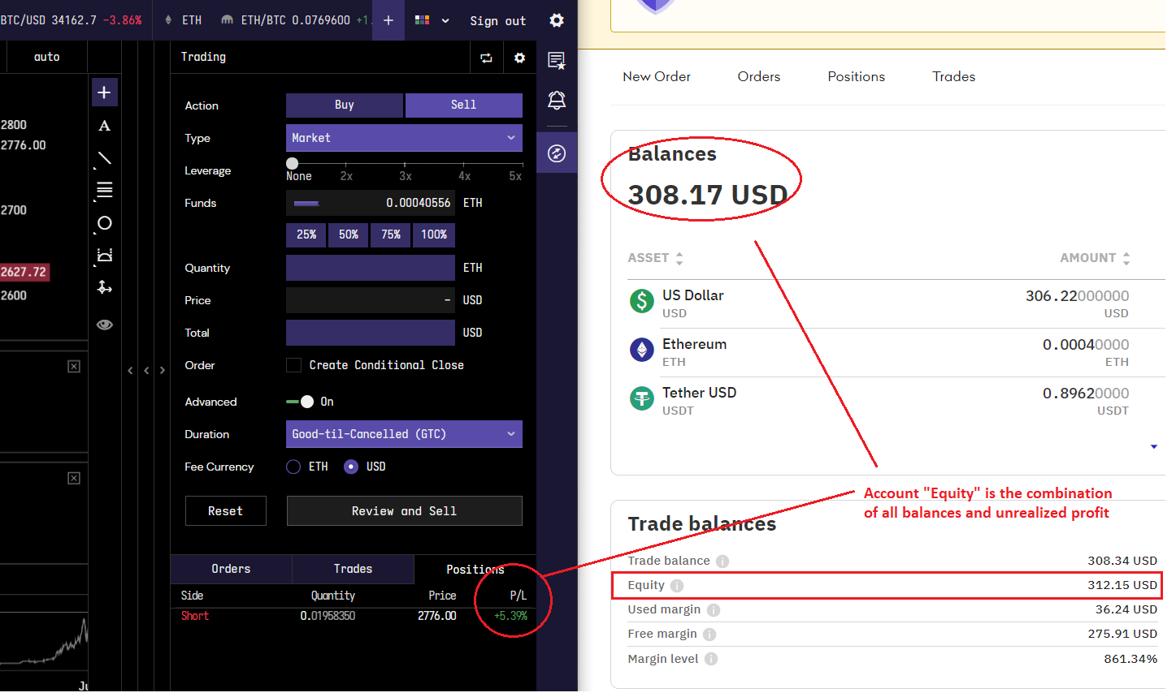

The issue is that the value we are pulling from does not reflect the balance that’s currently in the short position.

2 – Current Position Value

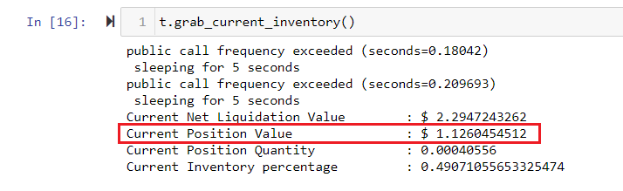

I think we are running into a similar issue with this variable as we are above. When the screen shot was taken, there was a large short position open for ETH. I took the screenshot first thing this morning when I began testing the updated script. There was a -.20 ETH position open… however, the position value reading we are seeing is only $1.12 – in actuality, the position value should have been approximately ~$310. Is it possible to have this reading also reflect the balance of short positions?

3 – Current Position Quantity

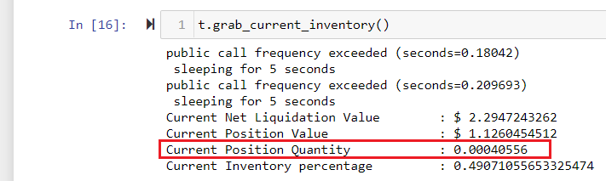

It looks like we are having the same issue here as we are with the other two variables above. The short position is not currently reflected in the Current Position Quantity variable. Just like the above, the screenshot was taken when there was a -.20 ETH position open, however, the Current Position Quantity currently reads close to zero. Ideally, this variable should read “-.20” (or whatever the balance of ETHUSD was at the time).